Software Development Life Cycle

What is the SDLC ?

It is a systematic framework which is used by the development team to build and deliver the software application as per the client’s requirement . SDLC helps us to break down a software development project into different phases that makes it easier to plan , gather , develop, test and deploy the software.

Below is the diagram that defines the various phases.

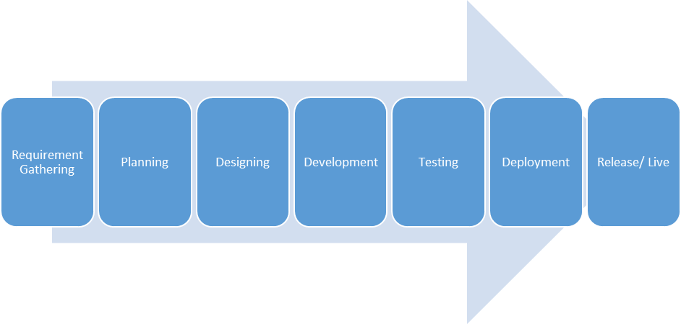

Requirement gathering

This is the first step in any software development lifecycle. We ask our client about the type of application and what all features we need to add.
- Type of application
- Features
- Give examples

Planning

This is the second phase where we decide the project timeline i.e estimated deadline in which we have to deliver the software and estimated cost of the project . For this, we create a development team and discuss all these important details with the team . And then we communicate all these details with the product owner .And then we move to the Designing phase once we get client’s approval.

Designing

The designing phase includes lots of parties such as developers, testers, DevOps team and managers who will handle this project . Here we decide the below technicality of the software.
- infrastructure
- Database
- Api design
- UI / UX of application

Developement

Developers or teams allocated actually start writing the code.

Testing

- features/ functionalities are tested here if are working properly
- Manual or automation testing

Deployment

- Deploy /run application on the decided environment (dev, test,production)
- We check if each and every feature is working properly using sanity testing so that we will be ready to handover this project to the client

Release / Live

- We deploy this code on the Production server.
- We handover this code / app to the client

Frameworks to apply SDLC

There are various SDLC models such as Waterfall , Agile but the decision to choose a particular model is based on various factors such as
- the complexity of the project
- Do we have a complete list of project requirement or likely to change during the development process

Let's take a small example:
Our client ABC wants us to develop a software to add , edit, update and delete school information .

AGILE :-

- `The agile model facilitates to add new requirements or features
- We divide applications in parts and each part is developed in a particular timeframe. This timeframe is called Sprint.
- We follow the whole sdlc process (from requirement gathering till the release/live stage) for each feature
- Let's take a small example in which our client ABC wants us to develop a software to add , edit, update and delete school information.
- The below image represents an Agile model.
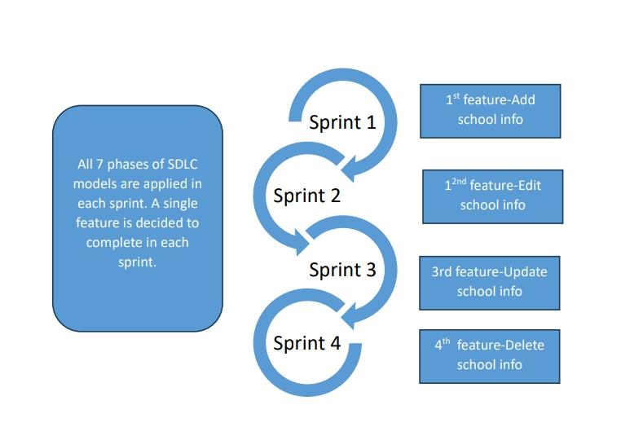

Let's take a small example in which our client ABC wants us to develop a software to add , edit, update and delete school information . So, the Agile model divides the software into multiple Sprints as per the feature and runs the below SDLC steps in iterations for each Sprint .Let’s explain for the first Sprint (assume 2 weeks ) which is for the first feature i.e Add school information.

- We gather requirements for the first feature i.e Add school information then do the planning like cost estimation and allocation of a development team
- Once planning is done, we move to the Designing phase in which developers , testers , devops team decide the infrastructure , database, ui/ux for the selected feature.
- After the designing phase, we move to the Development phase in which developers actually start writing code.
- The Testing phase run different test cases to check if the code works properly
- After the testing phase, we go to the Deployment phase in which we actually deploy the code as per the decided environment ( such as Dev , Test , Production ) . We do the sanity testing it in this phase to know if we can hand over the feature to the client
- The last phase is Release / Live in which we actually run the code on the production server and handover to the client.
So, as explained above, we have to iterate all the seven stages of the SDLC model for each feature . Here, our client can add new requirements during development of software since we use Sprints.

WATERFALL:-

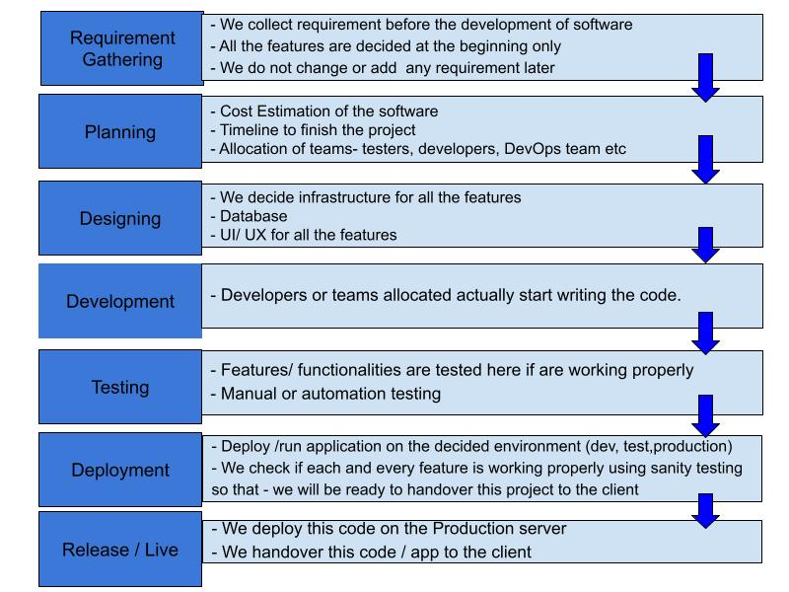

- Waterfall method is a linear software development model in which we gather all the requirements or features of software before development .
- Here, we don't break down an app into parts or features for development
- We move to the next phase of SDLC model only after completing the previous phase.
  - For example , we start from the first step of the sdlc method which is requirement gathering. Here we get requirements of all features and then only we move to the next step of sdlc which is planning.
  - Once we do the planning for all features which include cost estimation, allocation of team (testers, developers, devops team , managers etc) and project expected timeline then we go to the designing phase
  - In the Designing phase , the development team works on the infrastructure , database, ui / ux of the overall product .
  - After this, we go to the Development phase in which developers start writing code for all the features and then developers provide this code to the Testers which is the next phase of sdlc model- Testing .Here testers run manual / automated test cases and see if all features are working properly. If they face any issue then we have to go back to the Development phase.
  - Once all the testing is done, then only we move to the Deployment phase in which we deploy the code of all features combined and see if we are ready to hand over this project to the client using sanity testing.
  - Once the development phase is done successfully , then we reach the final phase of the SDLC model which is Release / live in which we finally give complete software to the client to run on the production server.
- As SDLC model is applied on all the features combined , it is slower than the Agile method

